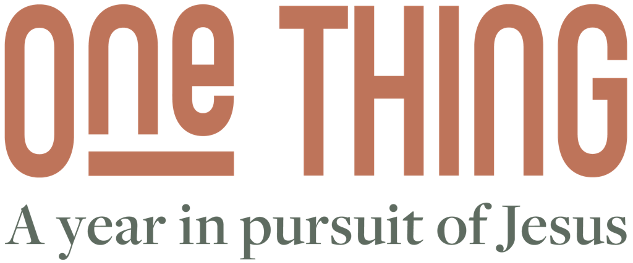


We’re thrilled you’re interested in applying for the One Thing year. This is an application for the upcoming year, starting in September. Once you have completed the form, email it to the address listed on page 5 of this document and we’ll be in touch to arrange an interview.

Which church are you interested in doing the One Thing year at?
(Please delete as appropriate)
Nottingham / Manchester / Birmingham / Newcastle

1. Personal Details

First & Last Name:

Address:

Phone number:

Email address:

Date of birth: _ _ / _ _ / _ _

Current relationship status: single / dating / engaged / married

Is your passport up-to-date? Yes / No

2. Health & Education
Do you consider yourself to have a disability? Yes / No
(If yes, please explain more in the text box below)

Would you benefit from additional support during the year? Yes / No
(If yes, please explain more in the text box below)

Do you have A-levels and/or a degree? Yes / No
(If yes, please expand in the text box below)

3. Church Life
What church are you currently part of?

How long have you been part of that church?

Are you part of a small group (home group or life group)? Yes / No
(If yes, please give the names of your group leaders)

Have you been baptised in water? Yes / No

Are you currently giving financially to a church? Yes / No

4. Why One Thing?
Why are you applying for the One Thing year?

What are some of your strengths?

What are some of your weaknesses?

What would you like to grow in over the course of the One Thing year?

Do you have an idea of which area of church life you’d like to work in?
(For example, kids’ ministry, media and production, social justice/compassion, youth etc)

Regarding part-time work alongside the year, do you have any existing plans or ideas about how you’d find work?
(If you’re applying to do One Thing at Grace Church Nottingham, please let us know if you’d be interested in applying for work with one of our Grace Enterprises businesses)

Regarding living arrangements, do you have any existing plans about where you’d live?
(Let us know if you’d appreciate support in this area)

Thank you for filling in this application. Please email this document to the church you’re applying to and we’ll be in touch very soon.

Grace Church Nottingham - onething@gracechurchnottingham.org
King’s Church Birmingham - hello@kingschurchbirmingham.org
Revelation Church Manchester - jemima@revelationmcr.co.uk
The River Church Newcastle - rick@theriverchurch.co.uk

This form will be treated in accordance with GDPR. Information will be shared, if at all, with the pastoral staff of the church you’re applying to.

